**St Mark’s Anglican Community School**

**Year 12 Psychology Topic Test**

**Unit 3: Biological Influences/Bases of Behaviour**

**Term 1, 2016**

***Reading time 5 minutes***

***Working time 50 minutes***

***Total marks 54 marks***

**______________________________________________________________**

**Question 1 (6 marks)**

Complete the chart below to best represent the **Nervous System**.

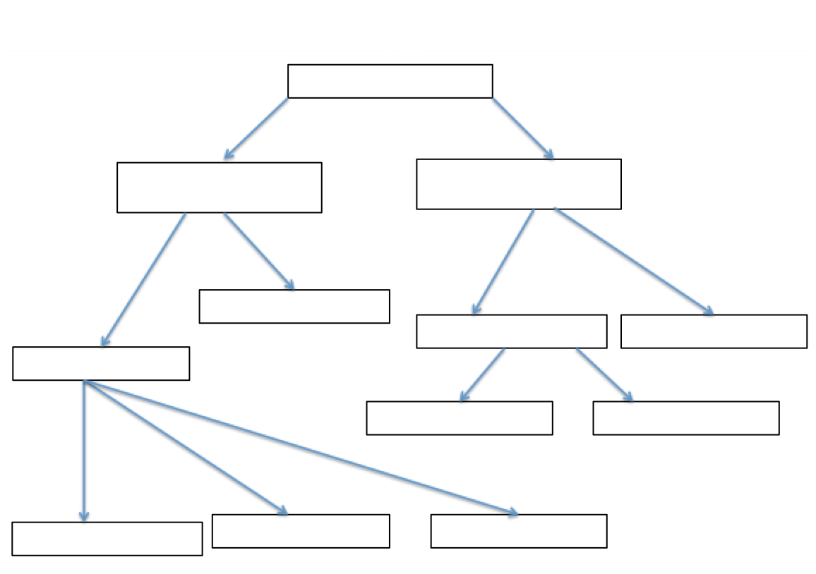

**Question 2 (8 marks)**

Complete the table below by naming the lobes of the brain and describing **one** main function of each lobe.

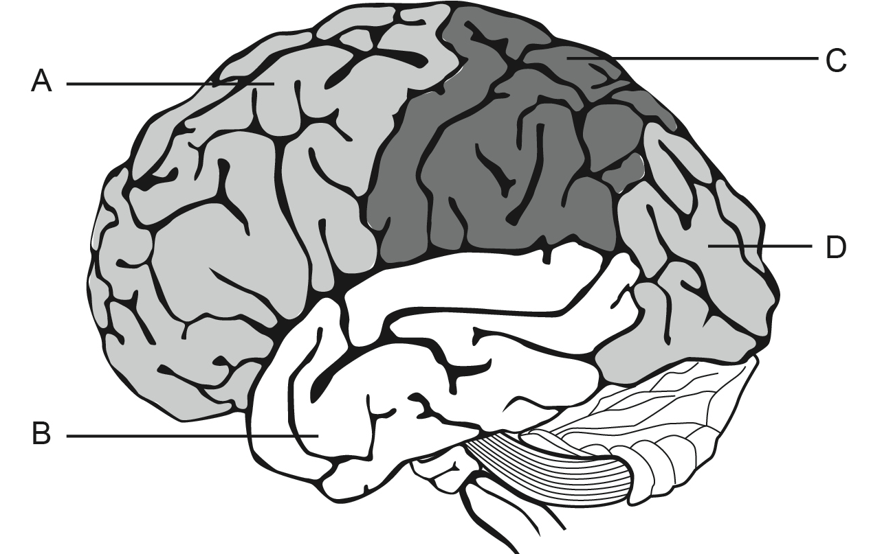

|  |  |  |
| --- | --- | --- |
|  | **Name of Lobe** | **Function** |
| **A** |  |  |
| **B** |  |  |
| **C** |  |  |
| **D** |  |  |

**Question 3 (5 marks)**

The spinal cord and brain together form the central nervous system. **Describe how the neural impulse travels from the sensory receptor to the muscle.** 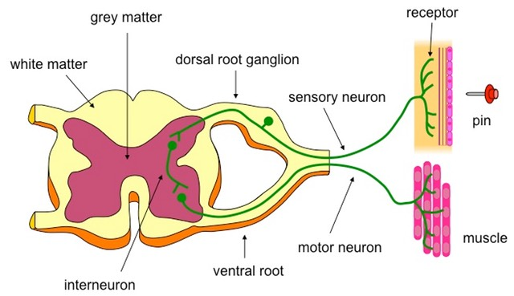

____________________________________________________________________________________________________________________________________________________________________________________________________________________________________________________________________________________________________________________________________________________________________________________________________________________________________________________________________________________________________________________________________________________________________________________________________________________________________________________________________________________________________________________________________________________________________________________________________________________________________________________________________________________________________

**Question 4 (4 marks)**

Outline **one structural** difference and **one functional** difference between a **motor neuron** and a **sensory neuron**.

|  |  |  |
| --- | --- | --- |
|  | **Structural** | **Functional** |
| **Motor Neuron** |  |  |
| **Sensory Neuron** |  |  |

**Question 5**

A person is sitting inside a quiet house watching television when suddenly there is a loud noise outside.

a) List **three** symptoms produced by the **autonomic nervous system** that the person might experience. **(3 marks)**

________________________________________________________________________________________________________________________________________________________________________________________________________________________________________________________________________________________________________________________________________________________________________________________________________________________________________________________________________________________________________________________________________________________________________________________________________________________________________________________

b) Name the division of the autonomic nervous system that is responsible for **producing** these symptoms. **(1 mark)** __________________________________________________________________________________________________________________________________________________________________________________________

c) Name the division of the autonomic nervous system that is responsible for the **reduction** of these symptoms. **(1 mark)**

__________________________________________________________________________________________________________________________________________________________________________________________

**Question 6**

The below diagram is a close up of the activity occurring in the synaptic gap between the dendrite of a neuron and the axon of another neuron.

**a)** Define neurotransmitter and give an example **(2 mark)**

**b)** Explain how neurotransmitters travel between neurons **(6 marks)**

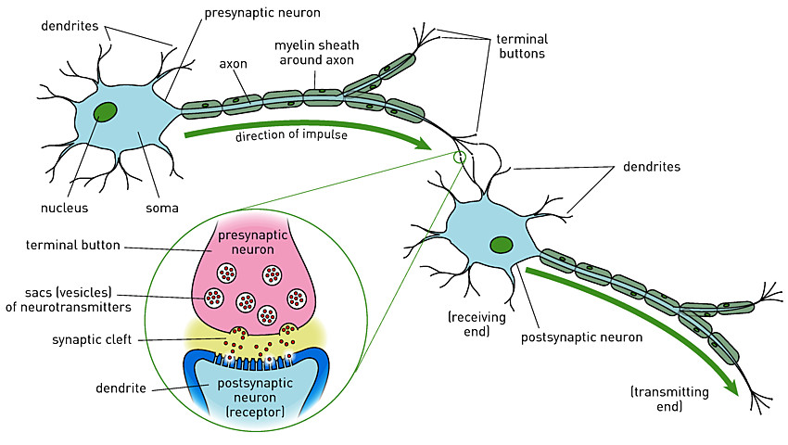________________________________________________________________________________________________________________________________________________________________________________________________________________________________________________________________________________________________________________________________________________________________________________________________________________________________________________________________________________________________________________________________________________________________________________________________________________________________________________________________________________________________________________________________________________________________________________________________________________________________________________________________________________________________________________________________________________________________________________________________________________________________

**Question 7 (6 marks)**

Hormones are chemical messengers produced by endocrine glands. Describe the **function** and **location** of the following glands in our body:

1. **Adrenal glands**:

______________________________________________________________________________________________________________________________________________________________________________________________________________________________________________________________________________________________________________________

1. **Thyroid glands**:

______________________________________________________________________________________________________________________________________________________________________________________________________________________________________________________________________________________________________________________

1. **Pituitary glands**:

______________________________________________________________________________________________________________________________________________________________________________________________________________________________________________________________________________________________________________________

**Question 8 (6 marks)**

Name **one physiological** and **one psychological** effect of each of the following classes of psychoactive drugs.

1. **Stimulants**

Physiological effect:

________________________________________________________________________________________________________________________________________________________________________________________________________________________________

Psychological effect:

________________________________________________________________________________________________________________________________________________________________________________________________________________________________

1. **Depressants**

Physiological effect:

________________________________________________________________________________________________________________________________________________________________________

Psychological effect:

________________________________________________________________________________________________________________________________________________________________________________________________________________________________

1. **Hallucinogens**

Physiological effect:

________________________________________________________________________________________________________________________________________________________________________________________________________________________________

Psychological effect:

________________________________________________________________________________________________________________________________________________________________________________________________________________________________

**Question 9 (6 marks)**

**Aphasia** is the impairment of language caused by damage to the brain. It is usually caused by a stroke and can affect talking, reading, writing and understanding others but it does not affect intelligence. In the table below, there are two types of aphasia. Fill in the blank boxes with the correct information.

|  |  |  |
| --- | --- | --- |
|  | **Broca’s Aphasia** | **Wernicke’s Aphasia** |
| **Location of Brain Damage (Lobe and Hemisphere)** |  |  |
| **Language Difficulties** |  |  |
| **Fluency of Speech** | Not fluent and requires effort | Very fluent but makes no sense |

**END OF TEST**